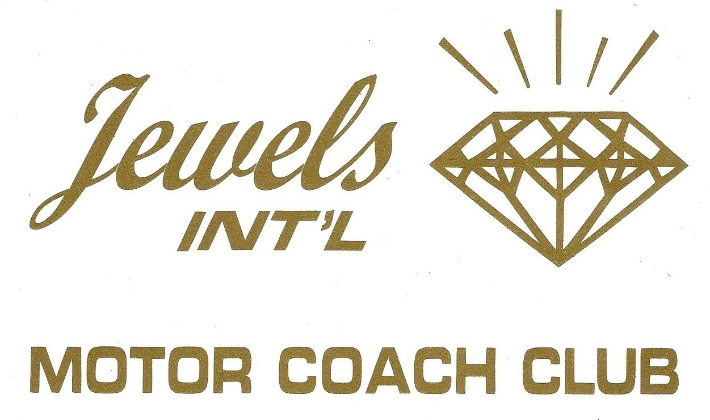

List of Rallies

1975 – July
Salem, Or
Founding Rally - 115 Members

1976 – February
Waco, TX

1976 – April
Lafayette, LA

1976 – July
Centreville, MI

1977 – February
Punta Gorda, FL

1977 – July
Syracuse, NY

1978 – February
Newell Plant, OK

1978 – July
Sioux Falls, SD

1979 – March
Big Oak, CA

1979 – April
Lafayette, LA

1979 – July
Richmond, VA

1980 – March
Big Oak, CA
1980 – July
St. Paul, MN

1981 – March
Riverview, FL

1981 – July
Denver, CO

1982 – March
Long Beach, CA

1982 – July
Elkhart, IN

1983 – March
Fredericksburg, TX

1983 – July
Stroudsburg, PA

1984 – March
Gulfport, MS

1984 – March
Leesburg, AL

1984 – July
De Forrest, WI

1985 – March
Tombstone, AZ

1985 – March
Laughlin, NV

1985 – July
Ilwaco, WA

1986 – February
San Diego, CA
1986 – March
Canyon Lake, TX

1986 – July
Knoxville, TV

1986 – July
Nashville, TN
combined with MCI

1986 – December
Pasadena, CA

1987 – January
Lake Havasu, AZ

1987 – March
Destin, FL

1987 – July
Oxford, IA

1987 – October
Dallas, TX
Texas State Fair

1988 – March
San Diego, CA
Sea World
1988 – July
South Bend, IN

1988 – December
Pasadena, CA

1989 – January
Ensenada, Mexico

1989 – March
Canyon Lake, TX

1989 – May
Balboa, CA

1989 – September
San Francisco, CA
1989 – October
Broken Bow, OK

1990 – April
Ft. Lauderdale, FL

1990 – June
Fairmont, MN

1990 – July
Winnipeg, Manitoba, Canada

1990 – October
Durango, CO, Santa Fe, NM, and Albuquerque, NM
Rolling Rally

1991 – March
Schertz, TX

1991 – November
Puerto Penasco, Mexico

1992 – March
Naples, FL
Crystal Lake

1992 – July
Estes Park, CO

1993 – January
Apple Valley, CA
Las Flores Ranch

1993 – March
Newport, CA

1993 – April
Wilton, CA, to Smartsville, CA
Rolling Rally

1993 – August
Asheville, NC

1993 – September
Branson, MO

1994 – April
New Orleans, LA

1994 – July
Calgary, Alberta, Canada

1995 – March
Tombstone, AZ

1995 – May
Sacramento, CA
The Barn

1995 – October
San Diego, CA

1996 – February
Palm Springs, CA

1996 – April
South Fork, TX

1996 – May
Louisville, KY
Kentucky Derby

1996 – July
Coeur d’ Alene, ID

1997 – March
Buellton, CA

1997 – May
Big Fork, MT

1997 – August
Durango, CO

1998 – March
Las Vegas, NV

1998 – June
Minneapolis, MN

1998 – August
Sun Valley, ID

1998 – October
Santa Cruz, CA to San Francisco, CA
Rolling Rally

1999 – March
Orlando, FL

1999 – September
Ellensburg, WA

2000 – March
Phoenix, AZ

2000 – July
Banff, Canada

2000 – October
New York, NY

2001 – February
Mamou, LA

2001 – June
Colorado Springs, CO

2001 – October
Tucson, AZ

2002 – March
Las Vegas, NV

2002 – May
Napa, CA

2002 – August
Seattle, WA
2003 – May
Kerrville, TX

2003 – October
Hollywood, CA

2004 – March
San Diego, CA

2004 – October
Ashville, NC

2005 – April
Branson, MO

2005 – October
San Francisco, CA

2006 – January
Pasadena, CA
Rose Parade

2006 – May
Santa Fe, NM

2006 – October
Kitchener, Ontario, Canada

2007 – February
Temecula, CA

2007 – April
Anacortes, Washington

2007 – October
Tulsa, OK

2008 – February
Coachella Valley, CA

2008 – May
Outer Banks, NC

2008 – August
Glacier Park, MT

2009 – May
Sacramento, CA, to Gold Country, CA
Rolling Rally

2009 – October
St. Louis, MO

2010 - May
College Station – Lake Travis, TX
Rolling Rally

2010 - September
Riverton, WY
Wyoming Roundup

20 11 – May
Des Moines, IA

2011 – May
Key West, FL

2012 - October
Gold Hill, OR

2012 – April
Las Vegas, NV

2013 – March
San Diego, CA

2013 – June
Ruidoso, NM

2013 – October
Denver, CO

2014 – September
Monterey, CA

2015 – April
Bridge, LA

2015 – September
Durango, CO

2016 – April
Fort McDowell, AZ
Valley of the Sun

2016 - October
Fall Colors Cruise
Canada - Boston

2017 – March
Hollywood, CA

2017 – October
Napa, CA

2018 – April
Louisville, KY
Kentucky Derby

2018 – September
Andover, SD
When Steam was King

2019 – April
Paso Robles

2019 – October
Albuquerque, NM
Balloon Festival

2021 – September
Grand Lake, OK

2022 – May
Valley Verde, AZ

2023 – January
Pasadena, CA
Rose Parade

2023 – October
Las Vegas, NV

2024 – September
Andover, SD
When Steam Was King
2025 – September
Chelan, WA

