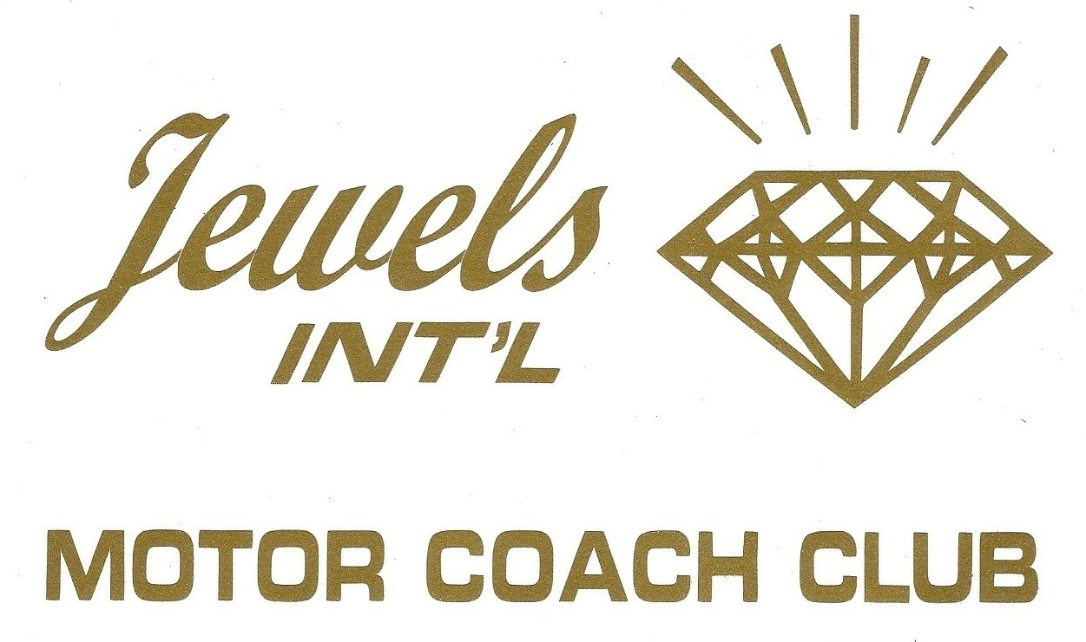

From Prospective Member to Installation
The Process and Who is Responsible

- Sponsor – Invites Prospective Member to Rally
- Trail Boss/Wagon Master – Notifies VP/Membership of all Prospective Members who have registered for a rally and who their sponsors are
- VP/Membership – Contacts the Sponsor of Prospective Members to discuss process and to send them the “First Time Guest Registration Form”
- Sponsor - Has Prospective Member fill out “First Time Guest Registration Form” and returns it to the VP/Membership
- Prospective Member – Attends 1st Rally
- Sponsor – Invites Prospective Member to 2nd Rally and notifies VP/Membership
- Trail Boss/Wagon Master – Notifies VP/Membership of all Prospective Members who have registered for a rally and who their sponsors are
- VP/Membership – Contacts the Sponsor of Prospective Member to discuss process and to send them the “Chapter Membership Application” Form
- Sponsor – Has Prospective Member fill out the “Chapter Membership Application” Form, and returns it to the VP/Membership, along with other required material
- VP/Membership orders official Jewels Name badges for 2nd time rally Prospective Member
- AT SECOND RALLY:
  - VP/Membership - collects any additional materials needed to complete the membership application
  - Sponsor – presents Prospective Member at Welcome Dinner
  - VP/Membership – presents Executive Board Members with copies of Membership Applications for all 2nd time Prospective Members
  - Executive Board – votes to Approve or Decline Membership
  - VP/Membership/Sponsors – Formally introduce Newly Installed Members who are presented with their official name badges, coach sign and Jewels decal

